A000-Am,C-Cemi-Owl-Cohoba Inhaler-Rhyolite-1000 CE

[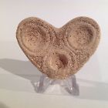](http://www.ebay.com/itm/262339688374?_trksid=p2057872.m2749.l2648&ssPageName=STRK:MEBIDX:IT)

Am,C-Cemi-Owl-Cohoba Inhaler-Rhyolite-1000 CE

**Case No.: 18**

**Accession No.**

**Formal Label:** Am,C-Cemi-Owl-Cohoba Inhaler-Rhyolite-1000 CE

**Display Description:**

Cemi owls were likely gods or spiritual representatives important to Taino cosmological inquiry. The consensus is they were not simply naturalistic owls, but symbolic representations. Owls were associated with the afterlife and allies of the *Behique* or shaman who sought their aid during hallucinogenic ventures.

The locations of these hallucinogenic ventures is sometimes marked by owl petroglyphs at especially sacred locations often by streams or rivers as in the following examples.

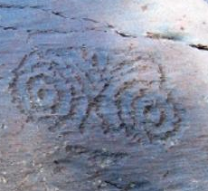

**Owl petroglyph from a boulder on the banks of the Rio Chacuey** in the Dominican Republic

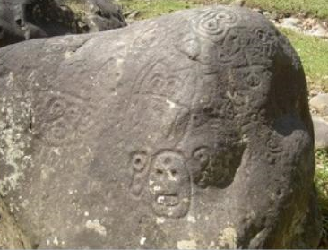

**Owl petroglyphs from a boulder on the banks of the Rio Yuboa**

**LC Classification: F 1909**

**Date or Time Horizon: 1000 CE**

**Geographical Area:** Originally from **Rio Chacuey** in the Dominican Republic

**Map:**

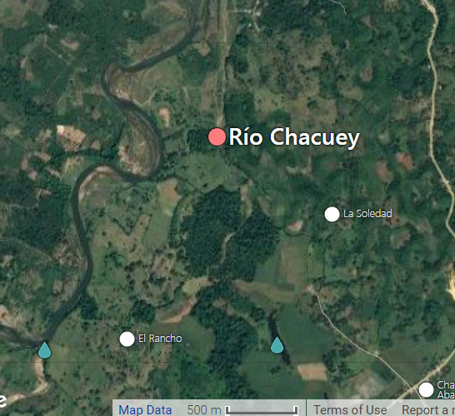

**GPS coordinates:** Latitude:  19° 7' 5.8" (19.1183°) north**;** Longitude:  70° 6' 46.8" (70.113°) west

**Cultural Affiliation: Taino**

**Medium: Rhyolite**

**Dimensions:** width 6.3cm or 2.4".

**Weight:**

**Condition:**

**Provenance:** from the vicinity of Rio Chacuey,Dominican Republic

**Discussion:**

**References:**

Scott, John F. (John Fredrik), 1985. Gainesville: University Gallery, College of Fine Arts, University of Florida: University Presses of Florida.